CURRICULUM VITAE

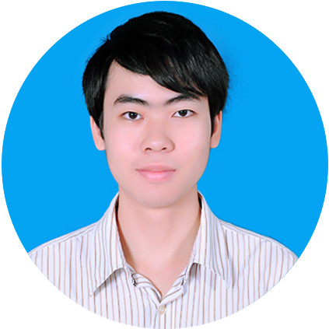

NGUYỄN TẤN SANG
nguyentansang3417@gmail.com
033 8948 429 - 0283.9965340

148/2A Quang Trung Street, Go Vap District, Ho Chi Minh City, Vietnam

November 28th, 2019

PERSONAL INFORMATION
Birthday : November 14th, 1996
Gender : Male

Year | Month | EDUCATION – WORKING EXPERIENCE
 |  | Working Experience
2019 | 4 | PHP Developer at POSTE CO., LTD | Started
2019 | 3 | Wordpress Developer at somotNET CO., LTD | Finished
2018 | 7 | Wordpress Developer at somotNET CO., LTD | Started
2018 | 4 | Intern at FUJI COMPUTER NETWORK CO., LTD | Finished
2018 | 1 | Intern at FUJI COMPUTER NETWORK CO., LTD | Started
 |  | Education
2018 | 12 | HCMC University of Technology (HUTECH) | Graduated
2014 | 10 | HCMC University of Technology (HUTECH) | Started
2014 | 8 | Tran Hung Dao High School | Graduated
2011 | 8 | Thong Tay Hoi Junior High School | Graduated
 |  | At home
2018 | 12 | Project: Develop website with Laravel  - Make a basic web app to research about Laravel  - CRUD with Authentication  - Authentication with Laravel  - Use Laravel Collective  - Access data from RESTful API
2018 | 7 | Project: Develop website with Wordpress  - Research and develope custom theme with purpose: optimize Wordpress theme.  - Make a simple, light theme by myself.  - Knowledge learning throught the project:  + Ability to understand theme’s structure  + Custom Post Type, Taxanomy  + Contact form in Wordpress  + How to create a simple plugin  + …  Link:  http://demo.smnet.vn/quangcaotaxi/
2017 | 12 | Project: Develop “My Japanese Dictionary” Website  -Make a simple website to view all Japanese vocabularies that I am learning  ; function: View vocabularies by Table  ; UI: Main page lists vocabularies from phpMyAdmin database using HTML, CSS and PHP.  ; library: jQuery  ; IDE: Adobe Dreamweaver; Editor: Sublime Text  Programing Language : PHP  HTML, CSS  * Personal project in localhost

TECHNICAL SKILLS – SOFT SKILLS
Technical Skills:

- Laravel Framework experiences
- Wordpress experiences
- Have knowledge about HTML, CSS, AJAX, basic Javascript, basic Jquery
- Use Photoshop in basic level (PSD to HTML, CSS; create GIF image)
- Design Responsive with @media query, framework Materialize, Bootstrap
- Develop PHP code with webserver (XAMPP, WAMPP), Visual Studio Code, Sublime Text
- Database: Microsoft SQL Server, MySQL (phpMyAdmin)
- Version Control: Use GitHub, GitBash with command line (push, pull)

Soft Skills:

- Learn from other people rapidly
- Search Google to resolve complex problems (english or vietnamese)
- Ability to read English document to debug error code
- Listening and Speaking basic English
- Ability to read Japanese in very basic level (learn by myself)
- Type Japanese with keyboard
- Remember Kanji, Write Kanji into notebook
- Japanese level is over N5
- Interested in working with Japanese people
- Follow Technology and Japanese websites
- Used to work with Japanese colleague, speaking language is English

Expectation
Training
Salary: Depend on my Ability
Type of Job: Fresher Job, Official Employee

