**PERSONAL INFORMATION**

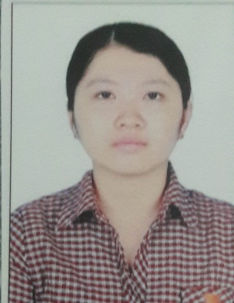**Date of Birth:** June 17, 1995

**Gender:** Female

**Marital status:**  Singel

**Phone:** 0964 480 520

**Email:** ntbhanh95@gmail.com

**Address:** Dongnai, Vietnam

**SKILLS**

**CAREER OBJECTIVE**

🕮Professional VP computer certificate B

🕮 English certificate B

🕮 Chinese HSK certificate 4

Become an excellent employee, accumulate more experience, train your job handling skills. I hope to work for a long time with a company with a professional and dynamic working environment. My knowledge, spirit, responsibility, my eagerness to learn will help me finish my job and become an excellent employee in the company.

**EDUCATION AND QUALIFICATIONS**

**TRÌNH ĐỘ HỌC VẤN**

**TRÌNH ĐỘ HỌC VẤN**

2010 -2013: Long Phuoc High School

2013 -2017 : Saigon University

Major: Business Administration

**WORK EXPERIENCE**

|  |  |  |
| --- | --- | --- |
| April 2018-Present | VeDan Viet Nam Enterprise Co., Ltd | Job Title :  Office Assistant Specialist |
| * Signing and receiving official letters sent from outside units, informing and distributing official dispatches for handling units. * Each month to monitor and update the dispatch progress report of each unit, then synthesize and submit a report to the managing levels for approval. * Direct hotline of the company, receive questions and requests from customers and transfer to relevant units for answers and handling. * Each quarter, to complete the Hotline monitoring report, submit to the managing levels for approval. * Support, do other jobs as directed by the Deputy Director. | | |

**INTERESTS**

 Tour discover

Read books & types of magazines



Listen to music, watch TV



 Listen to music, watch TV