socialist republic of vietnam
Independence - Freedom - Happiness
-------------------o0o--------------------

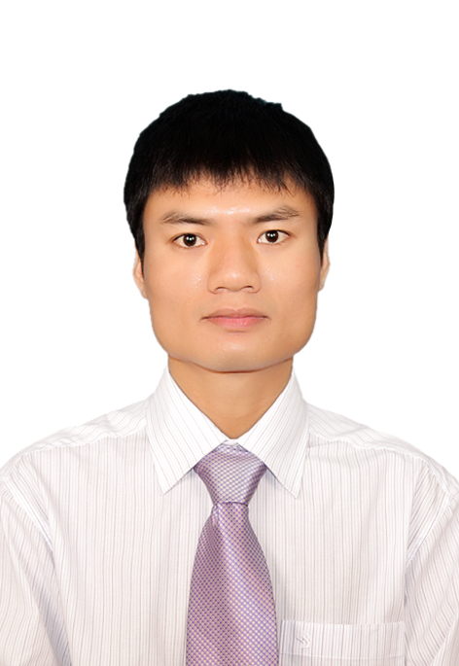

Curriculum vitae

FULL NAME: LE VIET TUNG
DATE OF BIRTH: December 18th 1983

CONTACT ADDRESS: 208 room – B Building – Dong Da collective zone, Le Hong Phong Street, Phu Nhuan Ward, Hue City, Thua Thien Hue province.
COUNTRY: VIET NAM
MOBILE: +84 – (0)906 181283
EMAIL: Mr.LeViet1812@gmail.com

Hue, 08/2019

RESUME
CONTACT INFORMATION
Name: LE VIET TUNG
Date of birth: December 18th 1983
Sex: Male

Place of birth: 3 hamlet, Hoang Phuong commune, Hoang Hoa district, Thanh Hoa province.
Marital status: Married.
Health status: Good
Mobile: +84 – (0)906 181283
Email: Mr.LeViet1812@gmail.com
Country: Viet Nam
--------------------------------------------------------------------------------
SUMMARY
I have over five years working at Petrovietnam Petrochemical and Textile Fiber Joint Stock Company (PVTEX) from 2009 to 2015. In the first phase of the PVTEX project, I had 10 months trained advanced level English and operation of simulation model at Petrovietnam manpower training college (PVMTC) in Vung Tau; 2 weeks practiced at the company of the equipment suppliers in Germany and 3 months practiced at the same factory in Guangzhou China.
After that, I am Production manager in Scavi jont stock company in Hue city, QA manager in Vinatex International TOMS Textile & Garment Co.,Ltd in Quang Tri province and now I’m deputy QA manager in Hanesbrand Hue Vietnam.
--------------------------------------------------------------------------------
- WORK EXPERIENCE
- Deputy QA manager in Hanesbrand Hue Vietnam (2018.08 – now)
- I manage 80 peoples with 05 quality team leader. Directly report to QA manager.
- Promote quality achievement and performance improvement throughout the organization
- Set QA compliance objectives and ensure that targets are achieved. Establish standards and clearly defined quality methods for staff
- Develop a plan, promote, facilitate and organize training activities for all respective persons related to product quality
- Develop and analyze statistical data and product specifications to determine present standards and establish proposed quality and reliability expectancy of finished product
- Maintain and improve product and operation quality by monitoring product requirements, SOP, compliance.
- Be responsible for buyers quality claim and giving on time buyer feedback in any quality issue
- Working with suppliers when materials input have problem about quality.
- QA manager in VTJ TOMS Textile & Garment Co.,Ltd (2016.10 – 2018.07) – the company production about Knitting, Dyeing and Sewing.
- The final product of the company is the T-shirt with total over 500 worker for knitting, dyeing and sewing.
- Our customers are TOMS from Japan and our products will be distributed in the market: Japan, Korea, China and some where other on the world.
- I’m Head of Quality management department – QA manager, management 56 peoples and directly management 12 quality team leader of knitting factory, dyeing factory, sewing factory and quality of material input of the company.
- Directly report to Genaral manager.
- My responsibility:
- Building product quality standards for process of knitting, dyeing, sewing and follow product standards of TOMS customers from Japan – JIS standard.
- Construction of the production process and quality control of production processes. Ensure quality system knitting, dyeing, sewing.
- Training, guidance QC staff and building quality control team of the company.
- Fabric quality control by use of 4 point system.
- Statistics, analysis of quality to prevent and anticipate hazards arising fault.
- Confirmation of the QC operation system during production.
- To held production meeting to review defect problems.
- Working with suppliers when materials input have problem about quality.
- Production manager of Scavi Joint Stock Company in Hue city (2016.04 – 2016.10) - the company about garment sector in Vietnam by France investment.
- Directly report to Vice general manager.
- The final products of the company are the underwear, swimwear, sportswear. The company with size over 5000 employees.
- I’m production manager of cutting 2 factory of the company with over 150 peoples and responsible for producing products for Decathlon, Hanesbrand, Target customers with over 42000pcs/day.
- Management and building system for ensuring the quality of fabric material before and during production.
- Production manager at Petrovietnam Petrochemical and Textile Fiber Joint Stock Company (PVTEX)
The company has more than 1000 workers in producing polyester fibers and yarns, supplying raw materials for Vietnam textile markets and on the world markets such as Turkey, Bangladesh...
- Operating engineer as trainee (2009.12 – 2010.09)
This is the first time I worked for PVTEX project, a project of Vietnam oil and gas group to invest in textile fiber industry of Vietnam. This time, I worked as trainee at Petrovietnam manpower training college (PVMTC) in Vung Tau of PVTEX project.
- Shift-leader operating engineer (2010.10 – 2013.07)
- I am responsible for the technical operation of technology and human resource management with over 40 peoples in production shift at the spinning DTY fiber and quality control sector.
- Directly report to Factory manager.
- Process and QA manager (2013.08 – 2013.10)
- Directly report to Factory manager and Vice general manager in charge of production.
- Directly management 10 peoples.
- Working and manage process team; responsible for testing, controlling and adjusting the process parameters to optimize the operation of the product quality.
- Construction and improvement of operational processes conform to ISO-9001:2008.
- Pre-production and QA manager of Filament unit at PVTEX company (2013.11 - 2015.04)
- Directly report to Factory manager and Vice general manager in charge of production.
- Directly management 12 peoples.
- Build and update the production planning weekly, monthly of Filament unit to follow the company's overall production planning.
- Summary daily reports of the production plans to the Filament unit manager and weekly, monthly reports to production department manager.
- I am responsible for control about providing and use of materials of filament unit.
- Monitor and manage raw materials suitable for produced in factory; in accordance with production safety standards and the rate of company's production targets.
- Working with suppliers to ensure quality stable raw material and replace promptly when problems arise about quality.
- Censorship records and participate directly in the procurement process of raw materials for Filament unit and factory of the company.
- Responsible for managing human resources as well as helped to management board of filament unit construction training programs and implement training about cognitive programs, improve the skills of staffs Filament unit with related departments.
- Monitor and manage pre-production team achieved KPIs of factory and the departments belong to Filament unit.
- Support leader of Filament unit to have clear view about KPIs of factory and company, as well as early warnings when problems arise.
- Working with the related departments, controlling, reviewing and improving operational processes, the quality control process issued conform to ISO.
- Ensure pre-production team working smooth conduct systematic, process, agreed regulation.
- Join resolve customer complaints with technician team.
- On the work of Unions (2013.06 – 2015.04, and at VTJ TOMS)
- From 2013/06 to 2014/05, I am a member of the union executive of filament unit; Chairman of the committee union checks filament unit.
- From 2014/06 to 2015/04, I am union president filament unit.
- At VTJ TOMS, I am a member of the union executive of VTJ TOMS.
--------------------------------------------------------------------------------
SKILLS
- Teamwork: I see myself as a team player in most situations. I also could work well on task require individual initiative and creative.
- Knowledgeable about Vietnam labor law.
- Good communication skills, trainning ...
- Fluency in Microsoft Office: Word, excel, powerpoint and some other software.
- English: Intermediate communication, English for other technical purposes.
--------------------------------------------------------------------------------
AWARDS
- Achieve title competitive soldiers base 4 years from 2011 to 2014 of the PVTEX company.
- Get certificate of merit by General manager of Vietnam oil and gas group to offer in 2014.
- Get certificate of merit of the Executive Union board of Vietnam oil and gas group donated in 2013 and 2014.
--------------------------------------------------------------------------------
EDUCATION
I graduated from Hanoi University of Science & Technology (HUST) in 2009 with a university degree in Textile fiber and garment technology.
In addition:
- In 2011/01, I have participated in “Training course covering electrical and mechanical maintenance of spinning machines with Wings-winder and Beltro-Guide system” at Barmag training centre of Oerlikon Barmag Zweigniederlassung der Oerlikon Textile GmbH & Co.KG in Remscheid Germany.
- In 2013/11, I have participated in “Training course on internal auditor according to ISO 9001:2008” at Apave Asia – Pacific company.
- In 2014/06, I have participated in training course “Cultivation of procurement professional” at Examine Management Economic and Traning Joint stock company (EDUPRO).
- In 2015/01, I have participated in training course “Production management skills, module – Production and operation management” at Asian institute of technology in Vietnam (AIT-VN).
- In 2015/01, I have participated in training course “Management skills for Leaders” at Asian institute of technology in Vietnam (AIT-VN).
--------------------------------------------------------------------------------
HOBBIES AND PERSONALITY
- I am a person has an inquiring mind, honesty, enthusiastic, creative, willing to learn, and willing to face difficulties.
- Like sport, movies, reading books, music, especially traveling.
--------------------------------------------------------------------------------
I certify that all the statements herein are true, complete, and correct to the best of my knowledge and look forward to the opportunity to cooperate and work with you as well as your company.
Hue, Aug 2018

Le Viet Tung

