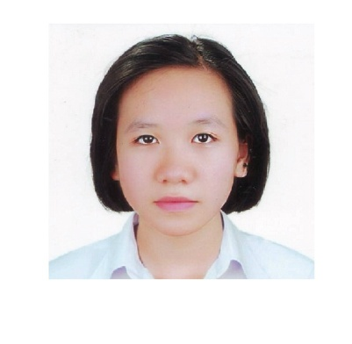 | Curriculum vitae  Diem Thi Kim Ngan
General Educational Development (GED) diploma  Degree classification: good  Year of graduation: 2015  Testing Center of GED: IPMAC  Address: 6th floor, VINAPACO Building, 142 Doi Can Street, Hanoi 100000, Viet Nam  Phone: 84 4 37710668  Basic nursing assistant diploma  Degree classification: good  Year of graduation: 2016  Ton That Tung Medical - Pharmaceutical Vocational School  Address: No.5 - 2nd Street - Canh Dong Quan area - Bich Dao ward - Ninh Binh city - Ninh Binh Province – Vietnam  Phone: 84 (91) 2353390 – 84 (30) 3893367  Email: ydyonthattung@gmail.com  JLPT Japanese-Language Proficiency Test - 日本語能力試験  Level: N3  Score Result: 146/180  Scoring section: Language knowledge: 57/60; Reading: 44/60; Listening: 45/60 |  | Birth year: 1998. Gender : Female  Birthplace: Gang Thep hospital – Trung Thanh ward – Thai Nguyen city – Thai Nguyen province - Vietnam  National ID number: 091872176  Permanent address: No.1080 - Feb 3rd street – 12 nd block - Tich Luong ward - Thai Nguyen city - Thai Nguyen province – Vietnam  Residential address: No.23 – 72nd Alley – Tay Mo (70th) Street – Tay Mo Ward - Nam Tu Liem District – Hanoi Capital City - Vietnam  Cell Phone: 84 (91) 3 765 624  Email: kimngan246789@gmail.com  Skype name: grain_sci
Coursework
- Daily English practice exercises
- Japanese language learning course (N4, N3)
- Four-seater car driver training course (B2)
- Motorcycle driver training course (A1)
- Basic nursing assistant training course
The Soft Skill
- Logical reasoning critical thinking abilities: Good.
- Searching and memorization skills: Fair.
- Computer practical skills in operating system: windows XP, 2000, win7 (familiar), win8.
- Microsoft Office application software (Word, Excel, PowerPoint): Basic understanding
- Communicate skills and presentation: Average.
- Adobe Photoshop CS6, Video Logo Remover: Daily Use
Language
- Vietnamese is my mother tongue language. So I am familiar with Vietnamese.
- English communication skills: Average; English grammar skills: Fair.
- Japanese: Listening: Fair; Speaking: Average; Reading: Good; Writing: Average.
Strengths
- Eagerness and always ready with new knowledge
- Having big loves to animals, plants, and scenery, …
- Good health, can withstand the pressure in work for a long period.
- Ready to work overtime.
- Can adapt to new environments.
Weaknesses
- Sometimes too much emotional, likely to oblivious.
- A bit timid at first, indecisive.
- Impatient.
Experiences
- Usage of Japanese and English language in work.
- Volunteer in Agriculture work.
Interests
- Reading: book (nature science, space science and formal science), story (all kind), grammar book, … ; Listening and talk: music (most of), story, logical conversation or argument, comedy, friendly talk, … ;
- Sport and game like: swimming, badminton, soccer, …bungee jumping, climbing the mountain, jungle forest adventure, sightseeing …
- Travelling by self or group: To the new cultures, new places, … to try and learn new things (like food, costume, … ).
- Surfing Internet.
Wishes
- Gain knowledge to enrich my mind while supporting my financy
- Train to manage and solve social problem in a better way.
- Have chance to sharpen my ability and enjoy new experiences
- Increase my value as a productive person.

